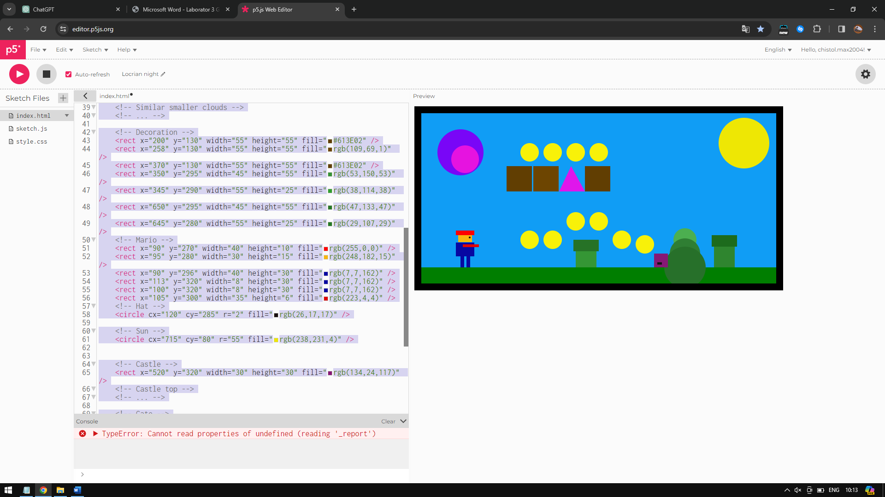

<!DOCTYPE html>

<html lang="en">

<head>

<meta charset="UTF-8">

<meta name="viewport" content="width=device-width, initial-scale=1.0">

<title>Super Mario SVG</title>

</head>

<body>

<svg width="800" height="400" xmlns="http://www.w3.org/2000/svg">

<!-- Background -->

<rect width="800" height="400" fill="rgb(16,157,245)" />

<!-- Ground -->

<rect x="0" y="350" width="800" height="55" fill="rgb(0,126,0)" />

<!-- Decorations -->

<circle cx="587" cy="290" r="25" fill="#4CAF50" />

<circle cx="587" cy="320" r="33" fill="#2F7E33" />

<circle cx="587" cy="350" r="45" fill="#27702A" />

<!-- Money -->

<circle cx="500" cy="300" r="20" fill="rgb(248,241,9)" />

<circle cx="450" cy="290" r="20" fill="rgb(248,241,9)" />

<circle cx="400" cy="250" r="20" fill="rgb(248,241,9)" />

<circle cx="350" cy="250" r="20" fill="rgb(248,241,9)" />

<circle cx="300" cy="290" r="20" fill="rgb(248,241,9)" />

<circle cx="250" cy="290" r="20" fill="rgb(248,241,9)" />

<circle cx="350" cy="100" r="20" fill="rgb(248,241,9)" />

<circle cx="400" cy="100" r="20" fill="rgb(248,241,9)" />

<circle cx="300" cy="100" r="20" fill="rgb(248,241,9)" />

<circle cx="250" cy="100" r="20" fill="rgb(248,241,9)" />

<!-- Clouds -->

<circle cx="100" cy="100" r="50" fill="rgb(121,6,247)" />

<circle cx="110" cy="115" r="30" fill="rgb(230,19,224)" />

<!-- Similar smaller clouds -->

<!-- ... -->

<!-- Decoration -->

<rect x="200" y="130" width="55" height="55" fill="#613E02" />

<rect x="258" y="130" width="55" height="55" fill="rgb(109,69,1)" />

<rect x="370" y="130" width="55" height="55" fill="#613E02" />

<rect x="350" y="295" width="45" height="55" fill="rgb(53,150,53)" />

<rect x="345" y="290" width="55" height="25" fill="rgb(38,114,38)" />

<rect x="650" y="295" width="45" height="55" fill="rgb(47,133,47)" />

<rect x="645" y="280" width="55" height="25" fill="rgb(29,107,29)" />

<!-- Mario -->

<rect x="90" y="270" width="40" height="10" fill="rgb(255,0,0)" />

<rect x="95" y="280" width="30" height="15" fill="rgb(248,182,15)" />

<rect x="90" y="296" width="40" height="30" fill="rgb(7,7,162)" />

<rect x="113" y="320" width="8" height="30" fill="rgb(7,7,162)" />

<rect x="100" y="320" width="8" height="30" fill="rgb(7,7,162)" />

<rect x="105" y="300" width="35" height="6" fill="rgb(223,4,4)" />

<!-- Hat -->

<circle cx="120" cy="285" r="2" fill="rgb(26,17,17)" />

<!-- Sun -->

<circle cx="715" cy="80" r="55" fill="rgb(238,231,4)" />

<!-- Castle -->

<rect x="520" y="320" width="30" height="30" fill="rgb(134,24,117)" />

<!-- Castle top -->

<!-- ... -->

<!-- Gate -->

<rect x="527" y="339" width="10" height="5" fill="rgb(18,17,19)" />

<!-- Border -->

<line x1="0" y1="0" x2="800" y2="0" stroke="black" stroke-width="30" />

<line x1="0" y1="0" x2="0" y2="800" stroke="black" stroke-width="30" />

<line x1="800" y1="0" x2="800" y2="900" stroke="black" stroke-width="30" />

<line x1="0" y1="400" x2="800" y2="400" stroke="black" stroke-width="30" />

<!-- Triangle -->

<polygon points="314,185 340,130 370,185" fill="rgb(223,22,235)" />

<!-- ... -->

</svg>

</body>

</html>